TASK 2: Access and Print the Element at a Given Index in an Array
Aim:
To write a Java program to access and print the element at a given index in an array.
Algorithm:
- Start the program.
- Declare and initialize an integer array.
- Read the index value from the user.
- Check whether the entered index is within the valid range.
- If the index is valid, display the corresponding array element.
- Otherwise, display "Invalid Index".
- Stop the program.
Program:
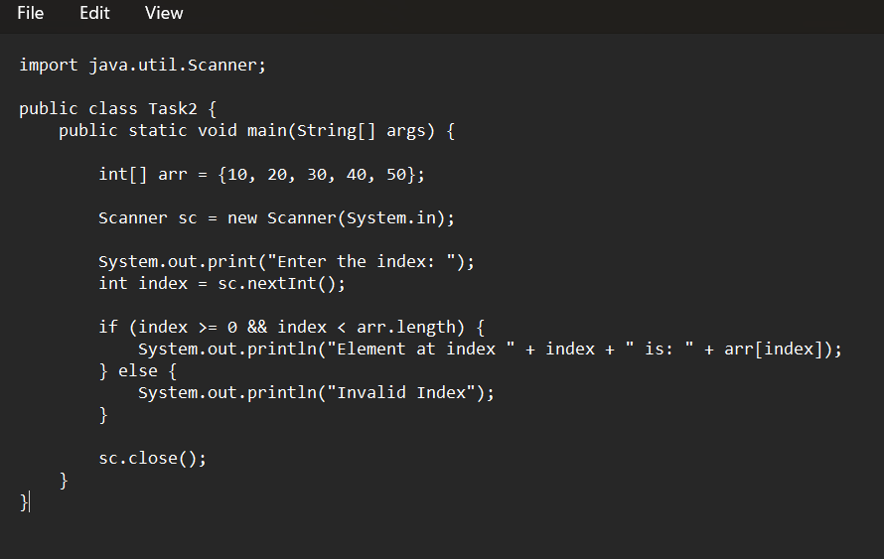Output:
Enter the index: 3
Element at index 3 is: 40
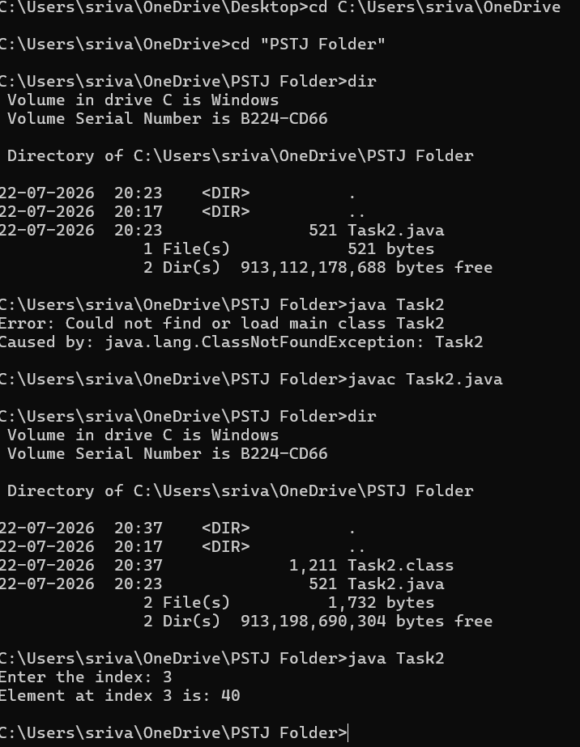

Result:
Thus, the Java program to access and print the element at a given index in an array was executed successfully.

TASK 3: Iterate Over an Array and Print All Elements
Aim:
To write a Java program to iterate over an array and print all the elements of an array.
Algorithm:
- Start the program.
- Declare and initialize an integer array.
- Use a for loop to traverse the array.
- Print each element of the array.
- Stop the program.
Program:
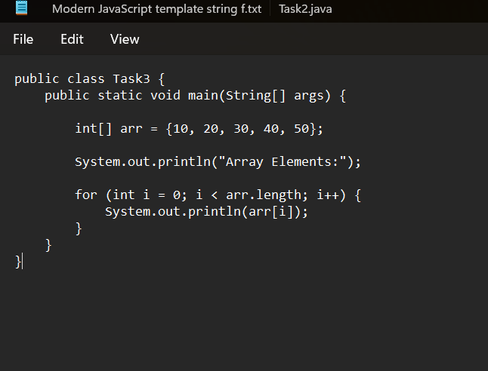
Output:
Array Elements:
10
20
30
40
50

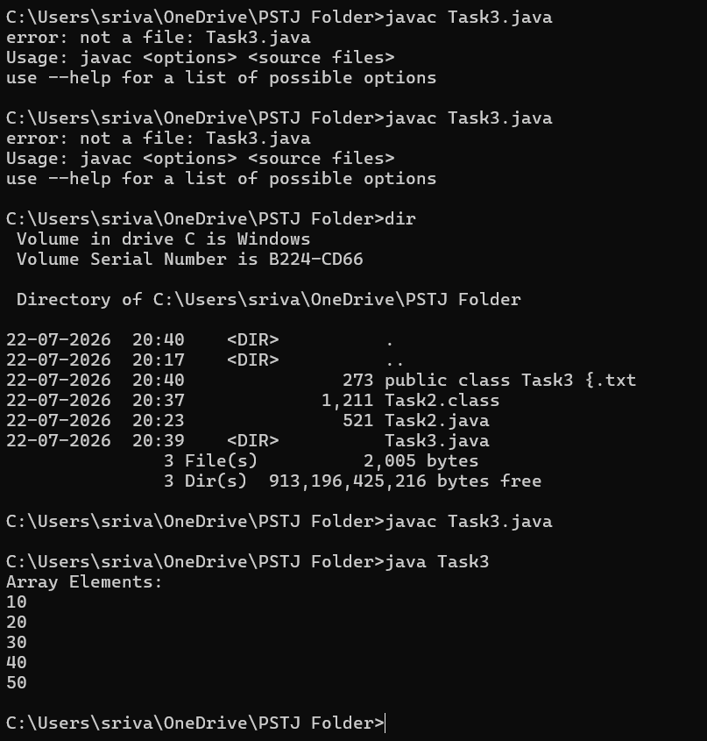
Result:
Thus, the Java program to iterate over an array and print all the elements of an array was executed successfully.

TASK 4: Find the Maximum Element in an Array of n Integers
Aim:
To write a Java program to find the maximum element present in an array of n integers.
Algorithm:
- Start the program.
- Declare and initialize an integer array.
- Assume the first element of the array as the maximum element.
- Traverse through the array using a loop.
- Compare each element with the current maximum value.
- If an element is greater than the maximum value, update the maximum value.
- Print the maximum element.
- Stop the program.
Program (Task4.java)
import java.util.Scanner;

public class Task4 {
public static void main(String[] args) {

Scanner sc = new Scanner(System.in);

System.out.print("Enter the number of elements: ");
int n = sc.nextInt();

int[] arr = new int[n];

System.out.println("Enter the array elements:");

for (int i = 0; i < n; i++) {
arr[i] = sc.nextInt();
}

int max = arr[0];

for (int i = 1; i < n; i++) {
if (arr[i] > max) {
max = arr[i];
}
}

System.out.println("Maximum element in the array is: " + max);

sc.close();
}
}

Output:
Example:
Enter the number of elements: 5
Enter the array elements:
12
45
7
89
23
Maximum element in the array is: 89
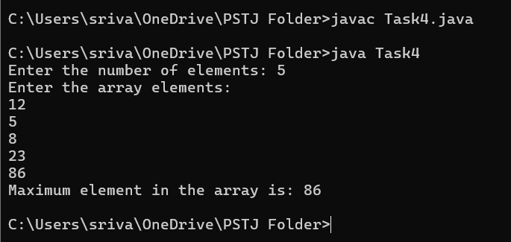
Result:
Thus, the Java program to find the maximum element in an array of n integers was executed successfully.

TASK 5: Find the Minimum Element in an Array of n Integers
Aim:
To write a Java program to find the minimum element present in an array of n integers.
Algorithm:
- Start the program.
- Declare and initialize an integer array.
- Assume the first element of the array as the minimum element.
- Traverse through the array using a loop.
- Compare each element with the current minimum value.
- If an element is smaller than the minimum value, update the minimum value.
- Print the minimum element.
- Stop the program.
Program (Task5.java):
import java.util.Scanner;

public class Task5 {
public static void main(String[] args) {

Scanner sc = new Scanner(System.in);

System.out.print("Enter the number of elements: ");
int n = sc.nextInt();

int[] arr = new int[n];

System.out.println("Enter the array elements:");

for (int i = 0; i < n; i++) {
arr[i] = sc.nextInt();
}

int min = arr[0];

for (int i = 1; i < n; i++) {
if (arr[i] < min) {
min = arr[i];
}
}

System.out.println("Minimum element in the array is: " + min);

sc.close();
}
}
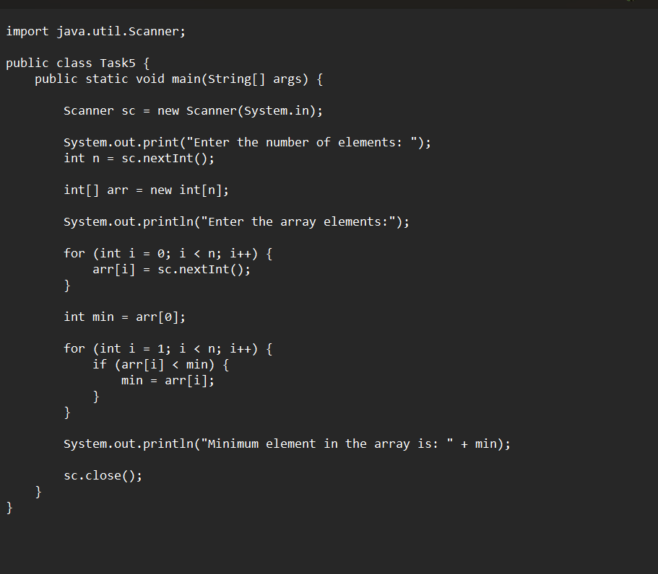

Output:
Example:
Enter the number of elements: 5
Enter the array elements:
12
45
7
89
23
Minimum element in the array is: 7
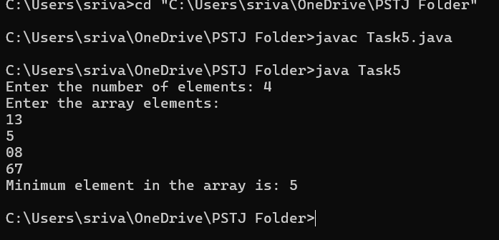

Result:
Thus, the Java program to find the minimum element in an array of n integers was executed successfully.

Task 6: Print all possible pairs of elements from an array of size n
Aim:To write a Java program to print all possible pairs of elements from an array.

Algorithm:
- Start the program.
- Read the number of elements (n) from the user.
- Read the array elements.
- Use two nested loops:
  - The outer loop selects the first element.
  - The inner loop selects the remaining elements after the first.
- Print each pair in the format (element1, element2).
- Stop the program.

Program:
import java.util.Scanner;

public class Task6 {
public static void main(String[] args) {
Scanner sc = new Scanner(System.in);

System.out.print("Enter the number of elements: ");
int n = sc.nextInt();

int[] arr = new int[n];

System.out.println("Enter the array elements:");
for (int i = 0; i < n; i++) {
arr[i] = sc.nextInt();
}

System.out.println("All possible pairs are:");

for (int i = 0; i < n - 1; i++) {
for (int j = i + 1; j < n; j++) {
System.out.println("(" + arr[i] + ", " + arr[j] + ")");
}
}

sc.close();
}
}

Sample Output:
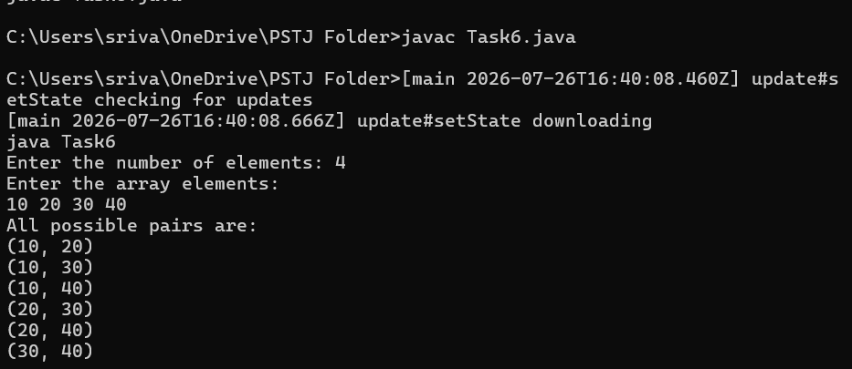
Enter the number of elements: 4
Enter the array elements:
10
20
30
40
All possible pairs are:
(10, 20)
(10, 30)
(10, 40)
(20, 30)
(20, 40)
(30, 40)

Result:
Thus, the Java program to print all possible pairs of elements from an array was executed successfully and the output was verified.

Task 7: Digit Sum Operation (Sum of Even or Odd Digits)
Aim
To write a Java program to calculate the sum of even digits or sum of odd digits of a given number based on the user's choice.
Algorithm
- Start.
- Read the number.
- Read the user's choice (1 for Even, 2 for Odd).
- Extract each digit using % 10.
- If choice is Even, add even digits.
- If choice is Odd, add odd digits.
- Display the sum.
- Stop.
Program (DigitSum.java)
import java.util.Scanner;

public class DigitSum {
public static void main(String[] args) {
Scanner sc = new Scanner(System.in);

System.out.print("Enter a number: ");
int num = sc.nextInt();

System.out.println("1. Sum of Even Digits");
System.out.println("2. Sum of Odd Digits");
System.out.print("Enter your choice: ");
int choice = sc.nextInt();

int sum = 0;
int temp = num;

while (temp > 0) {
int digit = temp % 10;

if (choice == 1 && digit % 2 == 0)
sum += digit;
else if (choice == 2 && digit % 2 != 0)
sum += digit;

temp /= 10;
}

System.out.println("Sum = " + sum);
}
}
Sample Output
Enter a number: 123456
1. Sum of Even Digits
2. Sum of Odd Digits
Enter your choice: 1
Sum = 12

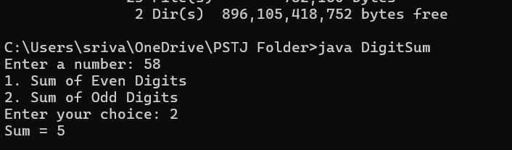 Result:
Thus, the Java program to find the sum of even or odd digits was executed successfully.

Task 8: Nth Fibonacci Number
Aim:
To write a Java program to find the Nth Fibonacci number.
Algorithm:
- Start.
- Read N.
- Initialize first = 0 and second = 1.
- Repeat until Nth term.
- Display the Nth Fibonacci number.
- Stop.
Program (NthFibonacci.java):
import java.util.Scanner;

public class NthFibonacci {
public static void main(String[] args) {
Scanner sc = new Scanner(System.in);

System.out.print("Enter N: ");
int n = sc.nextInt();

int first = 0, second = 1, next = 0;

if (n == 0)
System.out.println("Fibonacci Number = " + first);
else if (n == 1)
System.out.println("Fibonacci Number = " + second);
else {
for (int i = 2; i <= n; i++) {
next = first + second;
first = second;
second = next;
}
System.out.println("Fibonacci Number = " + next);
}
}
}
Sample Output:
Enter N: 8
Fibonacci Number = 21
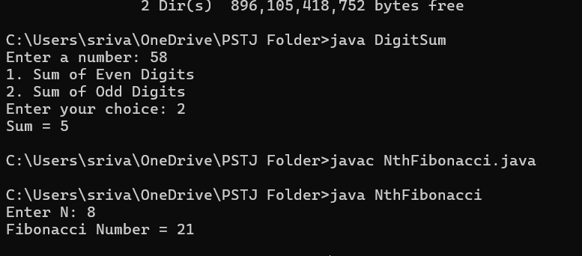
Result:
Thus, the Java program to find the Nth Fibonacci number was executed successfully.

Task 9: Palindrome Number
Aim:
To write a Java program to check whether a given number is a palindrome.
Algorithm:
- Start.
- Read the number.
- Reverse the number.
- Compare the reversed number with the original.
- If both are equal, print Palindrome.
- Otherwise, print Not Palindrome.
- Stop.
Program (PalindromeNumber.java):
import java.util.Scanner;

public class PalindromeNumber {
public static void main(String[] args) {
Scanner sc = new Scanner(System.in);

System.out.print("Enter a number: ");
int num = sc.nextInt();

int original = num;
int reverse = 0;

while (num > 0) {
int digit = num % 10;
reverse = reverse * 10 + digit;
num /= 10;
}

if (original == reverse)
System.out.println("Palindrome Number");
else
System.out.println("Not a Palindrome Number");
}
}
Sample Output:
Enter a number: 121
Palindrome Number
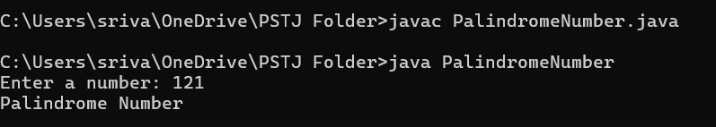
Result:
Thus, the Java program to check whether a number is a palindrome was executed successfully.

Task 10: Sum of Last Digit of Two Given Numbers
Aim:
To write a Java program to find the sum of the last digits of two given numbers.
Algorithm:
- Start.
- Read two numbers.
- Find the last digit of each number using % 10.
- Add the last digits.
- Display the result.
- Stop.
Program (LastDigitSum.java):
import java.util.Scanner;

public class LastDigitSum {
public static void main(String[] args) {
Scanner sc = new Scanner(System.in);

System.out.print("Enter first number: ");
int num1 = sc.nextInt();

System.out.print("Enter second number: ");
int num2 = sc.nextInt();

int last1 = num1 % 10;
int last2 = num2 % 10;

int sum = last1 + last2;

System.out.println("Sum of last digits = " + sum);
}
}
Sample Output
Enter first number: 456
Enter second number: 789
Sum of last digits = 15
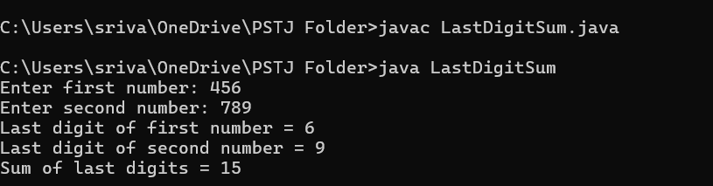
Result:
Thus, the Java program to find the sum of the last digits of two given numbers was executed successfully.

